#### Introduction to Java Programming - Using Eclipse

The following steps introduce you to Java programming through the Eclipse program.

**STEP 1 Open the Windows Eclipse Program**

To open Eclipse, the typical instructions are: on your **Desktop**, click the Start Button,

navigate to All Programs , migrate to Eclipse and point to and click on Eclipse .

If prompted, choose a workplace to store your project files.

From the Eclipse File menu, point to New and select Java Project . When the **New Java Project** window opens type the following as the name of your project: **First**

Click the Finish button.

Eclipse now creates the project.

From the Eclipse Window menu, point to Show View… and select Package Explorer .

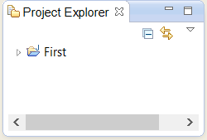

Navigate to the **Package Explorer**, right - click your project name, point to New and select Class .

When the **New File** dialog box opens, click the File name field and enter the appropriate file name.

In this case, use the file name **Sample** since this is the class name for the sample program included with these instructions. This step is important since to properly compile a Java program, the file name must match exactly the class name.

The class file will be stored in the src folder of the project.

Click Finish to close the **New File** dialog box.

**STEP 2 Type the Required Program Code**

Commence typing code within the Eclipse text editor. For this exercise, type the sample code for the class **Sample** which is given in **Figure 1** , which follows.  
 **STEP 3 Compile Your File**

From the Eclipse Project menu, ensure that the option Build Automatically is selected.

This will indicate that Eclipse will automatically build your project when you run it.

**Figure 1 Source Code for the Sample Program**

|  |
| --- |
| **/* Program to calculate the total cost */**  **/* Programmer: Sammy Student, File Name: Sample.java */**  **import javax.swing.JOptionPane;**  **import java.text.DecimalFormat;**  **public class Sample {**  **public static void main(String args[])**  **{**  **String firstNum, secondNum;**  **int num1,num2;**    **double grandtotal, subtotal, tax;**    **DecimalFormat twoDecimal = new DecimalFormat("0.00");**    **firstNum = JOptionPane.showInputDialog("Enter number of units");**  **secondNum = JOptionPane.showInputDialog("Enter unit price");**    **num1 = Integer.parseInt(firstNum);**  **num2 = Integer.parseInt(secondNum);**    **subtotal = num1 * num2;**  **tax = 0.06 * subtotal; // tax rate is 6 percent**  **grandtotal = subtotal + tax;**    **JOptionPane.showMessageDialog(null, " The total due is $"**  **+ twoDecimal.format(grandtotal), "Result",**  **JOptionPane.PLAIN_MESSAGE);**    **System.exit(0);**  **}**  **}** |

**STEP 4 Run Your Program**

Once you have completed compilation of your program, select Run on the menu bar, point to Run As and then click Java Application . Then click OK to launch your app.

If you do not have any errors, proceed to the next step, otherwise read the error messages and make any necessary corrections by comparing your screen code to

the original code shown within **Figure 1** . Then run your program again.

**STEP 5 Use Your Program**

When prompted by your program, enter 100 for the number of units and press

. Enter .

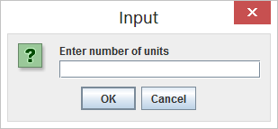

When prompted by your program, enter 5 for the unit price and press Enter .

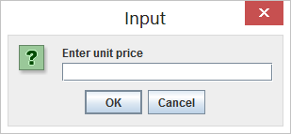

**STEP 6 Observe your Output**

After you enter the input items, the output is now displayed in a dialog box, namely:

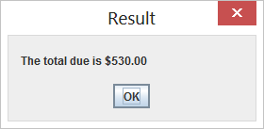

**STEP 7 Close Your File**

After you run the program, you can click File and Close All to run another program.